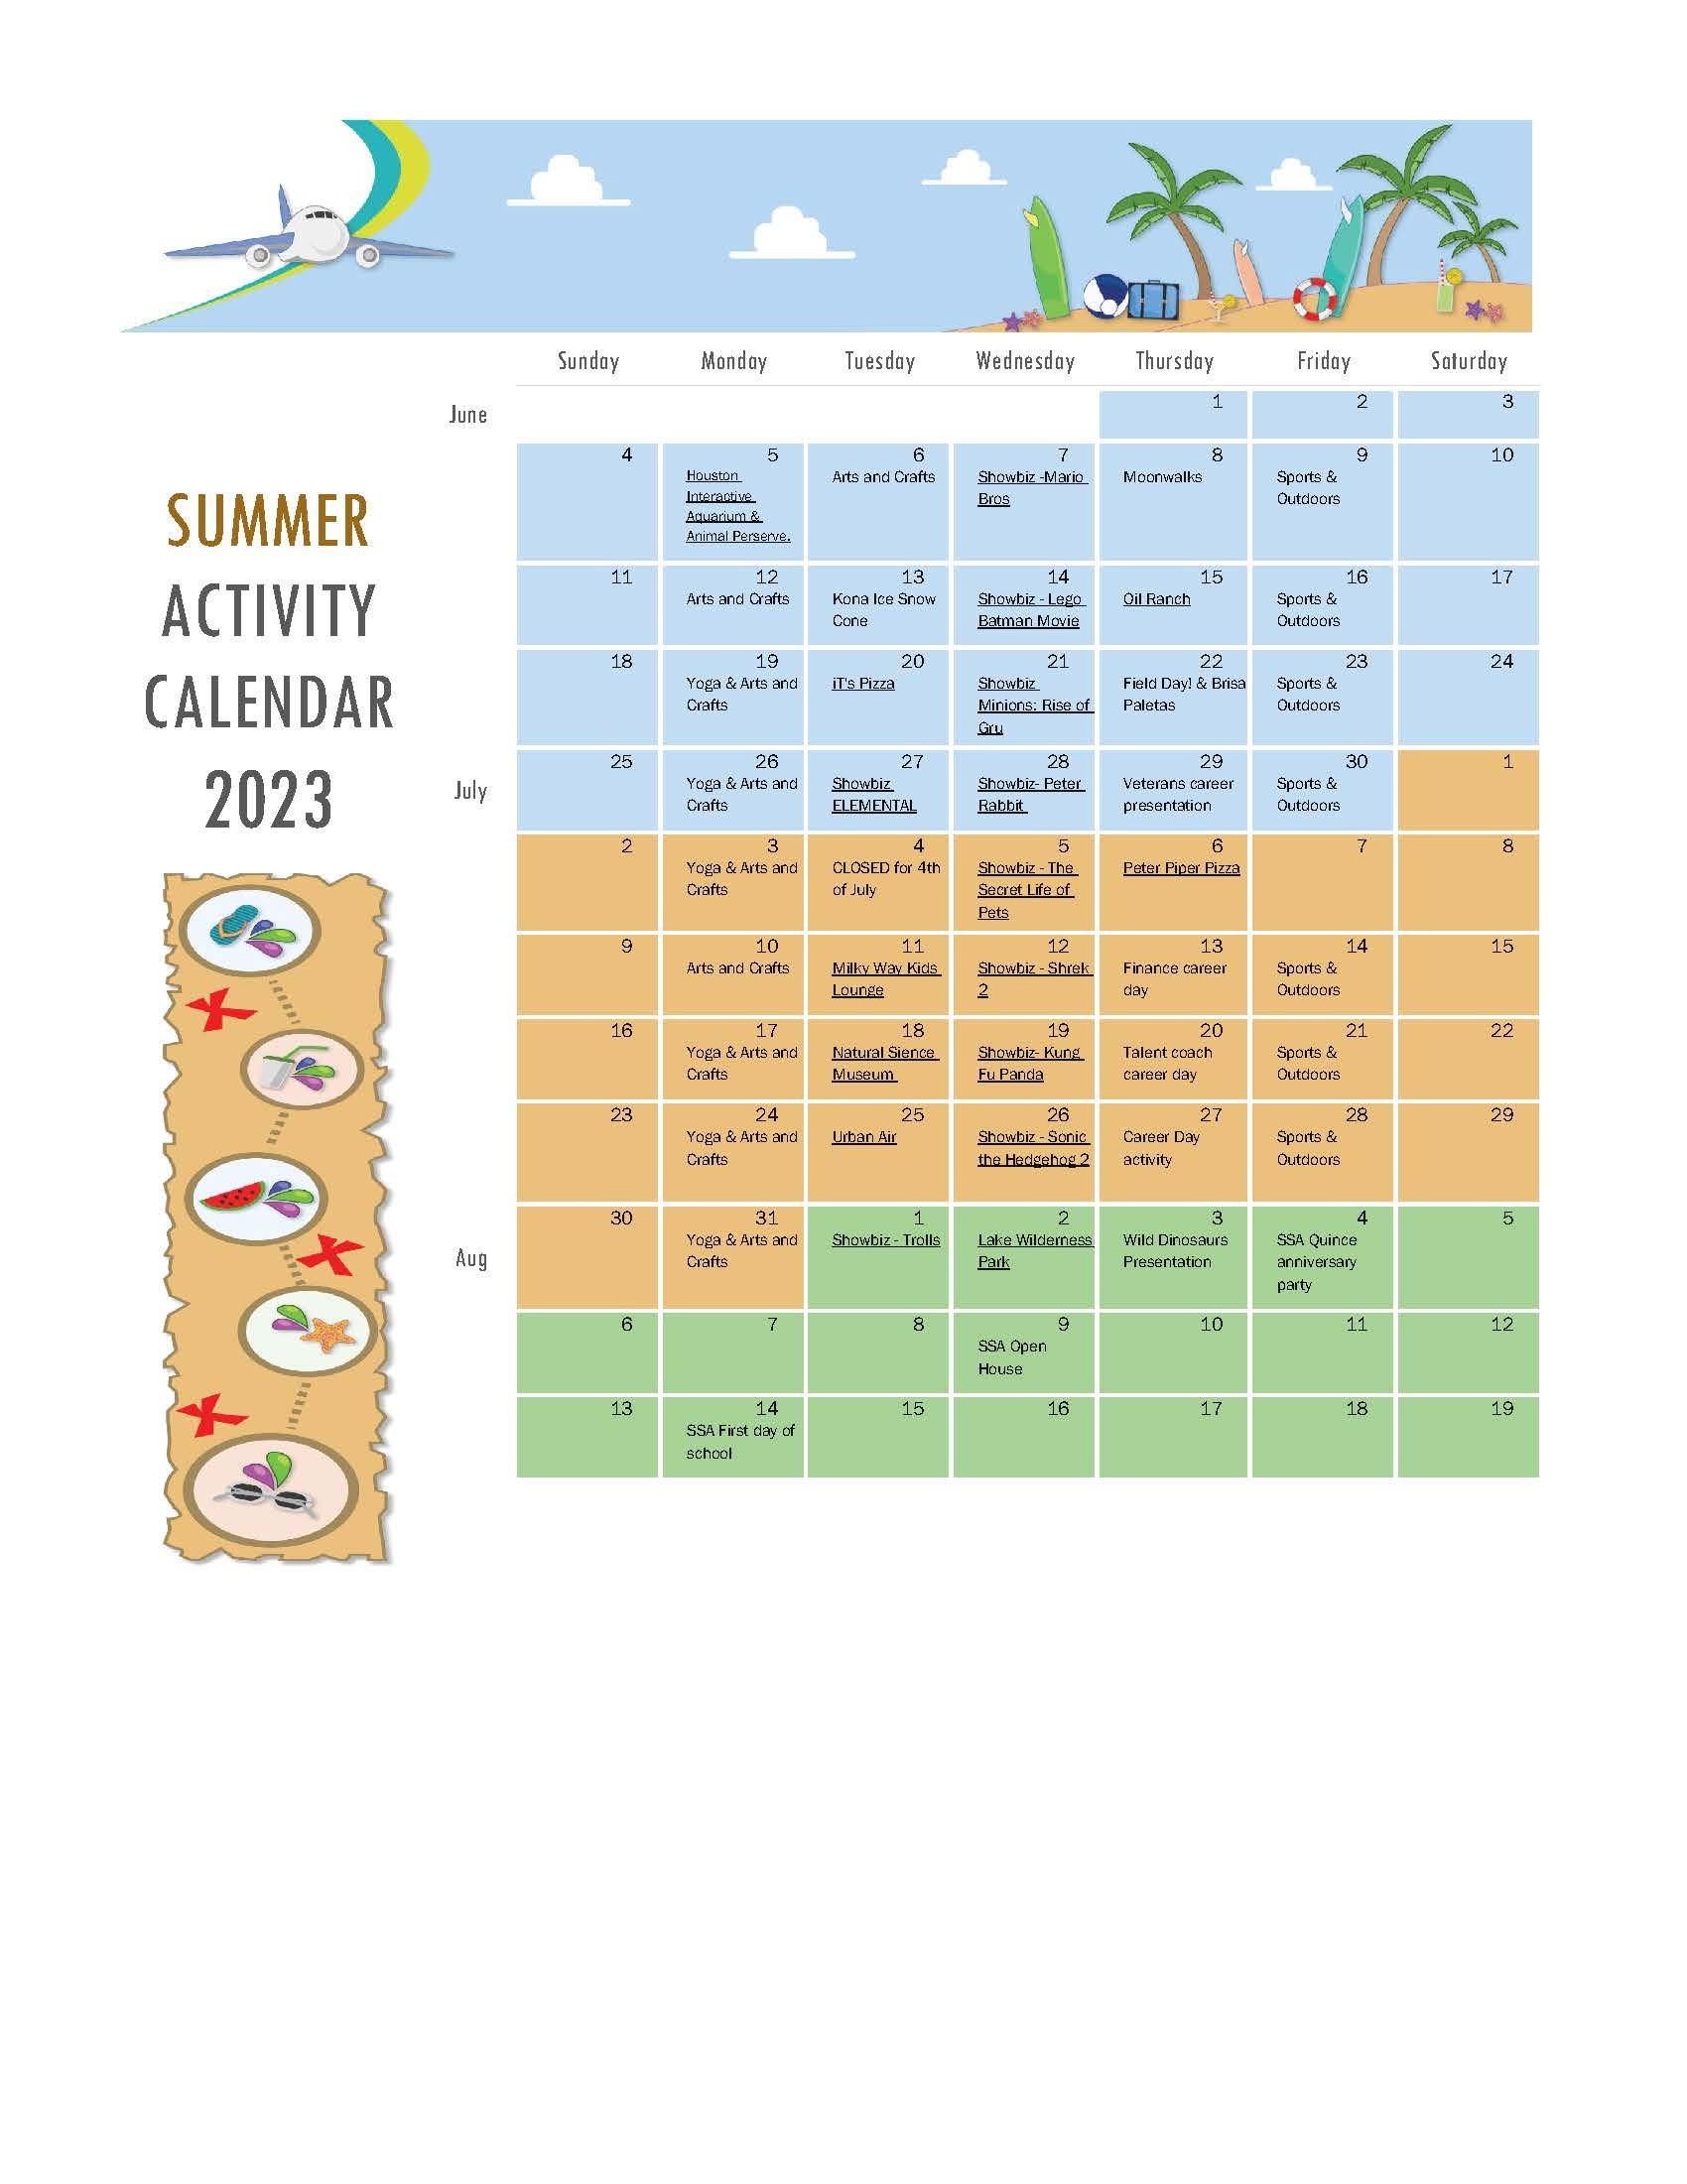
SILVER STAR ACADEMY
Summer Camp 2023 (Preschool-After School)
Summer Camp Registration Fee: $70
Weekly tuition $225 ($170 tuition + $55 activity fee)
JUNE & JULY FIELD TRIPS
June 05, 2023: Houston Interactive Aquarium & Animal Preserve
June 15, 2023: Oil Ranch
June 20, 2023: IT’z Pizza (Pasadena)
June 27, 2023: Showbiz Cinemas
July 06, 2023: Peter Piper Pizza
July 11, 2023: Milky Way Kids Lounge
July 18, 2023: Houston Museum of Natural Science
July 25, 2023: Urban Air (Humble)
August 02, 2023: Lake Wilderness Park
Other Scheduled Activities (all will take place @ Silver Star Academy):
Yoga Instructor: Once a week
Wild Dinosaurs – June 08, 2023
Sports Instructor: Once a week
Kona Snow Cone – June 13, 2023
Moon Walks – June 22, 2023
Spokes persons – 3 presentations (Career Days)
Field Day – August 03, 2023
Showbiz Cinemas: Once a week

**All students attending any Field Trip should be present no later than 8AM, please be on time. If you have any questions or concerns, please feel free to ask at the front desk. **
Summer Camp Permission Slip/Registration

Student’s Name:
D.O.B |  | **Registration fee and weekly activity fee will be drafted automatically with tuition.
Emergency Contact #1 : | Name__________________ Relationship to child:______________  Phone #:_________________
Emergency Contact #2: | Name__________________ Relationship to child:______________  Phone #:_________________
The Summer Camp reg. fee of $70 includes: 1 wrist band, 2 t-shirts, 1 hat, and a small backpack

Parents, please make sure that your child is here by 8AM, we will be leaving to all field trips at 8:30AM. If your child is not here on time, you must provide transportation for your child to our field trip’s destination, we will return from our field trips no later than 6PM. Also be prepared to provide towels, and sun screen when needed. Silver Star Academy will provide all of the children with sacked lunches, we will have coolers to put everybody’s lunches to keep them fresh. If you have any additional questions or concerns, please feel free to ask at the front office.

All summer Camp participants will attend to the following Field Trips in the months of June through July: Please sign & date next to each field trip that you give permission to.
Field Trip/Date | Parent Signature | Date | Volunteer
Monday - June 05, 2023
Houston Interactive Aquarium & Animal Preserve
5440 N Sam Houston Pkwy E, Humble, TX 77396
Thursday - June 15, 2023
Oil Ranch
23501 Macedonia Rd, Hockley, TX 77447
Tuesday - June 20, 2023
iT’Z Pizza – Pasadena
5950 Fairmont Pkwy. Pasadena, TX 77505
Tuesday - June 27, 2023
Showbiz Cinemas
7102 East Sam Houston Pkwy N, Houston, TX 77049
Thursday - July 06, 2023
Peter Piper Pizza
6223 East Sam Houston Pkwy N, Houston, TX 77049
Tuesday - July 11, 2023
Milky Way Kids Lounge
18379 Kuykendahl Rd. Spring, TX 77379
Tuesday - July 18, 2023
Houston Museum of Natural Science
5555 Hermann Park Dr, Houston, TX 77030
Tuesday - July 25, 2023
Urban Air – Humble Location
19304 US-59, Humble, TX 77338
Wednesday - August 02, 2023
Lake Houston Wilderness Park
25840 FM 1485, New Caney, TX 77357
June 07, 2023
ShowBiz Cinemas
7102 East Sam Houston Pkwy N, Houston, TX 77049
June 14, 2023
June 21, 2023
June 28, 2023
July 05, 2023
July 12, 2023
July 19, 2023
July 26, 2023
August 01, 2023
I ____________________________, give consent to Silver Star Academy for my child/ren____________________________________________, to attend the field trips listed above.
Parent Signature: ____________________________ Date: ________________

BEHAVIOR POLICY FOR SUMMER CAMP
Every child from Preschool – After School will be allowed to attend the field trips. However, parents please be aware that if your child is misbehaving while we are out on a field trip, they will not be allowed to attend any more activities outside of the building; unless a family member will be attending with them. Please understand that even though our teachers are trained for every situation, it’s also impossible for our teachers to offer one-on-one attention while we are outside of our center. Thank you for understanding and your cooperation.
-Silver Star Academy

Our ratios for classroom
3-year-old: 6 children per 1 teacher
4-year-old: 8 children per 1 teacher
5-year-old: 10 children per 1 teacher
6-12-years-old: 12 children per 1 teacher

Parents Signature: ________________________________________
Date: ________________

